**MOBILE APPLICATION DEVELOPMENT LAB**

**CYCLE 3**

1. **Simple login page using Relative Layout**

**Activity_main.xml**

<?xml version="1.0" encoding="utf-8"?>

<RelativeLayout

xmlns:android="http://schemas.android.com/apk/res/android"

xmlns:tools="http://schemas.android.com/tools"

android:id="@+id/activity_main"

android:layout_width="match_parent"

android:layout_height="match_parent"

android:background="#00CC99">

<EditText

android:id="@+id/text1"

android:hint="Username"

android:layout_width="match_parent"

android:layout_height="wrap_content"

android:layout_marginTop="150dp"

android:layout_marginLeft="18dp"

android:layout_marginRight="18dp"

android:padding="8dp"

android:background="#fff" />

<EditText

android:id="@+id/text2"

android:layout_width="match_parent"

android:layout_height="wrap_content"

android:layout_marginLeft="18dp"

android:layout_marginRight="18dp"

android:padding="8dp"

android:background="#fff"

android:hint="Password"

android:layout_marginTop="12dp"

android:layout_below="@+id/text1" />

<Button

android:id="@+id/b1"

android:layout_width="match_parent"

android:layout_height="wrap_content"

android:text="Login"

android:textColor="#00CC99"

android:layout_below="@+id/text2"

android:layout_marginTop="17dp"

android:layout_alignStart="@+id/text2"

android:layout_alignEnd="@+id/text2" />

<TextView

android:layout_width="wrap_content"

android:layout_height="wrap_content"

android:id="@+id/text3"

android:textColor="#fff"

android:text="Not a member?Sign up now"

android:layout_below="@+id/b1"

android:layout_centerHorizontal="true"

android:layout_marginTop="34dp" />

</RelativeLayout>

**MainActivity.java**

package com.codedost.loginscreen;

import android.support.v7.app.AppCompatActivity;

import android.os.Bundle;

public class MainActivity extends AppCompatActivity {

@Override

protected void onCreate(Bundle savedInstanceState) {

super.onCreate(savedInstanceState);

setContentView(R.layout.activity_main);

}

}

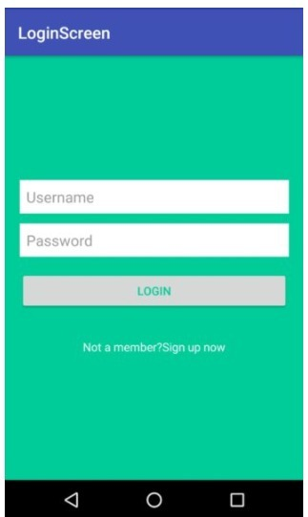

1. **Array Adapter with list view**

**activity_main.xml**

<?xml version="1.0" encoding="utf-8"?>

<RelativeLayout

xmlns:android="http://schemas.android.com/apk/res/android"

xmlns:tools="http://schemas.android.com/tools"

android:layout_width="match_parent"

android:layout_height="match_parent"

tools:context=".MainActivity">

<ListView

android:id="@+id/simpleListView"

android:layout_width="match_parent"

android:layout_height="wrap_content" />

</RelativeLayout>

**item_view.xml**

<?xml version="1.0" encoding="utf-8"?>

<LinearLayout

xmlns:android="http://schemas.android.com/apk/res/android"

android:layout_width="match_parent"

android:layout_height="match_parent"

android:orientation="vertical">

<TextView

android:id="@+id/itemTextView"

android:layout_width="match_parent"

android:layout_height="wrap_content"

android:layout_gravity="center" />

</LinearLayout>

**MainActivity.java**

import android.os.Bundle;

import android.widget.ArrayAdapter;

import android.widget.ListView;

import androidx.appcompat.app.AppCompatActivity;

public class MainActivity extends AppCompatActivity {

ListView simpleListView;

// array objects

String courseList[] = {"C-Programming", "Data Structure", "Database", "Python",

"Java", "Operating System", "Compiler Design", "Android Development"};

@Override

protected void onCreate(Bundle savedInstanceState) {

super.onCreate(savedInstanceState);

setContentView(R.layout.activity_main);

simpleListView = (ListView) findViewById(R.id.simpleListView);

ArrayAdapter<String> arrayAdapter = new ArrayAdapter<String>(this,

R.layout.item_view, R.id.itemTextView, courseList);

simpleListView.setAdapter(arrayAdapter);

}

}

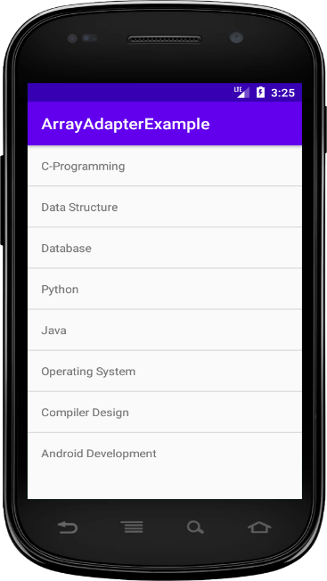

1. **Develop an application that toggle image using frame format**

**Activity_main.xml**

<FrameLayout xmlns:android="http://schemas.android.com/apk/res/android"

android:layout_width="fill_parent"

android:layout_height="fill_parent">

<ImageView

android:id="@+id/imageview"

android:layout_width="fill_parent"

android:layout_height="fill_parent"

android:scaleType="fitCenter"

android:src="@drawable/piq1" />

<Button

android:id="@+id/next"

android:layout_width="wrap_content"

android:layout_height="30dp"

android:layout_marginBottom="15dp"

android:layout_marginRight="10dp"

android:layout_gravity="bottom|right"

android:paddingTop="2dp"

android:paddingBottom="2dp"

android:background="@drawable/buttonback"

android:textColor="#000000"

android:text="Next" />

</FrameLayout>

**MainActivity.java**

import android.app.Activity;

import android.os.Bundle;

import android.view.View;

import android.widget.Button;

import android.widget.ImageView;

public class Piqlout extends Activity {

@Override

protected void onCreate(Bundle savedInstanceState) {

// TODO Auto-generated method stub

super.onCreate(savedInstanceState);

setContentView(R.layout.piq);

Button next= (Button) findViewById(R.id.next);

if (next.getText().equals("Next")) {

next.setOnClickListener(new View.OnClickListener() {

@Override

public void onClick(View v) {

// TODO Auto-generated method stub

ImageView img = (ImageView) findViewById(R.id.imageview);

img.setImageResource(R.drawable.piq2);

Button next= (Button) findViewById(R.id.next);

next.setText("Prev");

}

});

}

if (next.getText().equals("Prev")){

next.setOnClickListener(new View.OnClickListener() {

@Override

public void onClick(View v) {

// TODO Auto-generated method stub

ImageView img = (ImageView) findViewById(R.id.imageview);

img.setImageResource(R.drawable.piq1);

Button next= (Button) findViewById(R.id.next);

next.setText("Next");

}

});

}

}

1. **Demonstrate Activity Life Cycle**

**Activity_main.xml**

<?xml version="1.0" encoding="utf-8"?>

<android.support.constraint.ConstraintLayout xmlns:android="http://schemas.android.com/apk/res/android"

xmlns:app="http://schemas.android.com/apk/res-auto"

xmlns:tools="http://schemas.android.com/tools"

android:layout_width="match_parent"

android:layout_height="match_parent"

tools:context="example.javatpoint.com.activitylifecycle.MainActivity">

<TextView

android:layout_width="wrap_content"

android:layout_height="wrap_content"

android:text="Hello World!"

app:layout_constraintBottom_toBottomOf="parent"

app:layout_constraintLeft_toLeftOf="parent"

app:layout_constraintRight_toRightOf="parent"

app:layout_constraintTop_toTopOf="parent" />

</android.support.constraint.ConstraintLayout>

**MainActivity.java**

package example.javatpoint.com.activitylifecycle;

import android.app.Activity;

import android.os.Bundle;

import android.util.Log;

public class MainActivity extends Activity {

@Override

protected void onCreate(Bundle savedInstanceState) {

super.onCreate(savedInstanceState);

setContentView(R.layout.activity_main);

Log.d("lifecycle","onCreate invoked");

}

@Override

protected void onStart() {

super.onStart();

Log.d("lifecycle","onStart invoked");

}

@Override

protected void onResume() {

super.onResume();

Log.d("lifecycle","onResume invoked");

}

@Override

protected void onPause() {

super.onPause();

Log.d("lifecycle","onPause invoked");

}

@Override

protected void onStop() {

super.onStop();

Log.d("lifecycle","onStop invoked");

}

@Override

protected void onRestart() {

super.onRestart();

Log.d("lifecycle","onRestart invoked");

}

@Override

protected void onDestroy() {

super.onDestroy();

Log.d("lifecycle","onDestroy invoked");

}

}

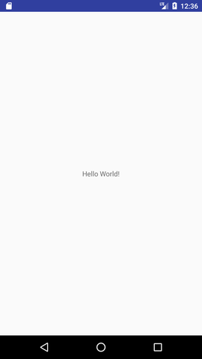

onCreate, onStart and onResume methods are invoked.

Now click on the HOME Button. You will see onPause method is invoked.

Now see on the emulator. It is on the home. Now click on the center button to launch the app again.

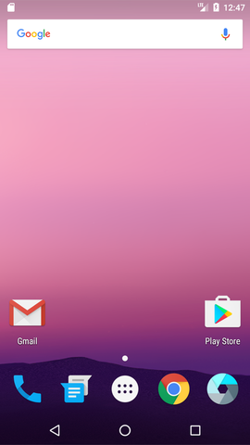

Now click on the lifecycleactivity icon.

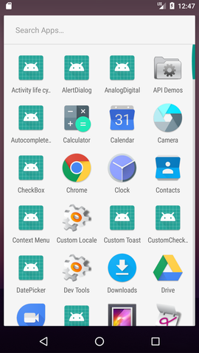

onRestart, onStart and onResume methods are invoked.

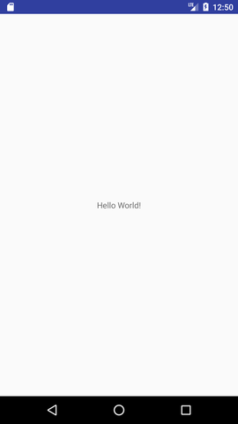

Now click on the back button. Now you will see onPause methods is invoked.

After a while, you will see onStop and onDestroy methods are invoked.

1. **Taking camera and saving the picture**

**Mainactivity.xml**

<?xml version="1.0" encoding="utf-8"?>

<RelativeLayout xmlns:android="https://schemas.android.com/apk/res/android"

xmlns:app="https://schemas.android.com/apk/res-auto"

xmlns:tools="https://schemas.android.com/tools"

android:id="@+id/content_main"

android:layout_width="match_parent"

android:layout_height="match_parent"

android:paddingBottom="@dimen/activity_vertical_margin"

android:paddingLeft="@dimen/activity_horizontal_margin"

android:paddingRight="@dimen/activity_horizontal_margin"

android:paddingTop="@dimen/activity_vertical_margin"

android:background="#000000"

app:layout_behavior="@string/appbar_scrolling_view_behavior"

tools:context="com.journaldev.imagepicker.MainActivity"

tools:showIn="@layout/activity_main">

<RelativeLayout

android:layout_width="250dp"

android:layout_height="250dp"

android:layout_centerHorizontal="true"

android:layout_centerVertical="true"

android:background="@drawable/image_border"

android:clickable="true"

android:orientation="vertical">

<ImageView

android:id="@+id/imageView"

android:layout_width="match_parent"

android:layout_height="match_parent"

android:adjustViewBounds="true"

android:scaleType="centerCrop" />

</RelativeLayout>

<de.hdodenhof.circleimageview.CircleImageView

android:id="@+id/img_profile"

android:layout_width="100dp"

android:layout_height="100dp"

android:layout_gravity="center_horizontal"

android:src="@drawable/profile"

app:civ_border_width="5dp"

app:civ_border_color="#FFFFFF"

android:layout_alignParentBottom="true"

android:layout_centerHorizontal="true" />

</RelativeLayout>

**MainActivity.java**

public class MainActivity extends AppCompatActivity {

Bitmap myBitmap;

Uri picUri;

private ArrayList permissionsToRequest;

private ArrayList permissionsRejected = new ArrayList();

private ArrayList permissions = new ArrayList();

private final static int ALL_PERMISSIONS_RESULT = 107;

@Override

protected void onCreate(Bundle savedInstanceState) {

super.onCreate(savedInstanceState);

setContentView(R.layout.activity_main);

Toolbar toolbar = (Toolbar) findViewById(R.id.toolbar);

setSupportActionBar(toolbar);

FloatingActionButton fab = (FloatingActionButton) findViewById(R.id.fab);

fab.setOnClickListener(new View.OnClickListener() {

@Override

public void onClick(View view) {

startActivityForResult(getPickImageChooserIntent(), 200);

}

});

permissions.add(CAMERA);

permissionsToRequest = findUnAskedPermissions(permissions);

//get the permissions we have asked for before but are not granted..

//we will store this in a global list to access later.

if (Build.VERSION.SDK_INT >= Build.VERSION_CODES.M) {

if (permissionsToRequest.size() > 0)

requestPermissions(permissionsToRequest.toArray(new String[permissionsToRequest.size()]), ALL_PERMISSIONS_RESULT);

}

}

@Override

public boolean onCreateOptionsMenu(Menu menu) {

// Inflate the menu; this adds items to the action bar if it is present.

getMenuInflater().inflate(R.menu.menu_main, menu);

return true;

}

@Override

public boolean onOptionsItemSelected(MenuItem item) {

// Handle action bar item clicks here. The action bar will

// automatically handle clicks on the Home/Up button, so long

// as you specify a parent activity in AndroidManifest.xml.

int id = item.getItemId();

//noinspection SimplifiableIfStatement

if (id == R.id.action_settings) {

return true;

}

return super.onOptionsItemSelected(item);

}

/**

* Create a chooser intent to select the source to get image from.<br />

* The source can be camera's (ACTION_IMAGE_CAPTURE) or gallery's (ACTION_GET_CONTENT).<br />

* All possible sources are added to the intent chooser.

*/

public Intent getPickImageChooserIntent() {

// Determine Uri of camera image to save.

Uri outputFileUri = getCaptureImageOutputUri();

List allIntents = new ArrayList();

PackageManager packageManager = getPackageManager();

// collect all camera intents

Intent captureIntent = new Intent(android.provider.MediaStore.ACTION_IMAGE_CAPTURE);

List listCam = packageManager.queryIntentActivities(captureIntent, 0);

for (ResolveInfo res : listCam) {

Intent intent = new Intent(captureIntent);

intent.setComponent(new ComponentName(res.activityInfo.packageName, res.activityInfo.name));

intent.setPackage(res.activityInfo.packageName);

if (outputFileUri != null) {

intent.putExtra(MediaStore.EXTRA_OUTPUT, outputFileUri);

}

allIntents.add(intent);

}

// collect all gallery intents

Intent galleryIntent = new Intent(Intent.ACTION_GET_CONTENT);

galleryIntent.setType("image/*");

List listGallery = packageManager.queryIntentActivities(galleryIntent, 0);

for (ResolveInfo res : listGallery) {

Intent intent = new Intent(galleryIntent);

intent.setComponent(new ComponentName(res.activityInfo.packageName, res.activityInfo.name));

intent.setPackage(res.activityInfo.packageName);

allIntents.add(intent);

}

// the main intent is the last in the list (fucking android) so pickup the useless one

Intent mainIntent = allIntents.get(allIntents.size() - 1);

for (Intent intent : allIntents) {

if (intent.getComponent().getClassName().equals("com.android.documentsui.DocumentsActivity")) {

mainIntent = intent;

break;

}

}

allIntents.remove(mainIntent);

// Create a chooser from the main intent

Intent chooserIntent = Intent.createChooser(mainIntent, "Select source");

// Add all other intents

chooserIntent.putExtra(Intent.EXTRA_INITIAL_INTENTS, allIntents.toArray(new Parcelable[allIntents.size()]));

return chooserIntent;

}

/**

* Get URI to image received from capture by camera.

*/

private Uri getCaptureImageOutputUri() {

Uri outputFileUri = null;

File getImage = getExternalCacheDir();

if (getImage != null) {

outputFileUri = Uri.fromFile(new File(getImage.getPath(), "profile.png"));

}

return outputFileUri;

}

@Override

protected void onActivityResult(int requestCode, int resultCode, Intent data) {

Bitmap bitmap;

if (resultCode == Activity.RESULT_OK) {

ImageView imageView = (ImageView) findViewById(R.id.imageView);

if (getPickImageResultUri(data) != null) {

picUri = getPickImageResultUri(data);

try {

myBitmap = MediaStore.Images.Media.getBitmap(this.getContentResolver(), picUri);

myBitmap = rotateImageIfRequired(myBitmap, picUri);

myBitmap = getResizedBitmap(myBitmap, 500);

CircleImageView croppedImageView = (CircleImageView) findViewById(R.id.img_profile);

croppedImageView.setImageBitmap(myBitmap);

imageView.setImageBitmap(myBitmap);

} catch (IOException e) {

e.printStackTrace();

}

} else {

bitmap = (Bitmap) data.getExtras().get("data");

myBitmap = bitmap;

CircleImageView croppedImageView = (CircleImageView) findViewById(R.id.img_profile);

if (croppedImageView != null) {

croppedImageView.setImageBitmap(myBitmap);

}

imageView.setImageBitmap(myBitmap);

}

}

}

private static Bitmap rotateImageIfRequired(Bitmap img, Uri selectedImage) throws IOException {

ExifInterface ei = new ExifInterface(selectedImage.getPath());

int orientation = ei.getAttributeInt(ExifInterface.TAG_ORIENTATION, ExifInterface.ORIENTATION_NORMAL);

switch (orientation) {

case ExifInterface.ORIENTATION_ROTATE_90:

return rotateImage(img, 90);

case ExifInterface.ORIENTATION_ROTATE_180:

return rotateImage(img, 180);

case ExifInterface.ORIENTATION_ROTATE_270:

return rotateImage(img, 270);

default:

return img;

}

}

private static Bitmap rotateImage(Bitmap img, int degree) {

Matrix matrix = new Matrix();

matrix.postRotate(degree);

Bitmap rotatedImg = Bitmap.createBitmap(img, 0, 0, img.getWidth(), img.getHeight(), matrix, true);

img.recycle();

return rotatedImg;

}

public Bitmap getResizedBitmap(Bitmap image, int maxSize) {

int width = image.getWidth();

int height = image.getHeight();

float bitmapRatio = (float) width / (float) height;

if (bitmapRatio > 0) {

width = maxSize;

height = (int) (width / bitmapRatio);

} else {

height = maxSize;

width = (int) (height * bitmapRatio);

}

return Bitmap.createScaledBitmap(image, width, height, true);

}

/**

* Get the URI of the selected image from {@link #getPickImageChooserIntent()}.<br />

* Will return the correct URI for camera and gallery image.

*

* @param data the returned data of the activity result

*/

public Uri getPickImageResultUri(Intent data) {

boolean isCamera = true;

if (data != null) {

String action = data.getAction();

isCamera = action != null && action.equals(MediaStore.ACTION_IMAGE_CAPTURE);

}

return isCamera ? getCaptureImageOutputUri() : data.getData();

}

@Override

protected void onSaveInstanceState(Bundle outState) {

super.onSaveInstanceState(outState);

// save file url in bundle as it will be null on scren orientation

// changes

outState.putParcelable("pic_uri", picUri);

}

@Override

protected void onRestoreInstanceState(Bundle savedInstanceState) {

super.onRestoreInstanceState(savedInstanceState);

// get the file url

picUri = savedInstanceState.getParcelable("pic_uri");

}

private ArrayList findUnAskedPermissions(ArrayList wanted) {

ArrayList result = new ArrayList();

for (String perm : wanted) {

if (!hasPermission(perm)) {

result.add(perm);

}

}

return result;

}

private boolean hasPermission(String permission) {

if (canMakeSmores()) {

if (Build.VERSION.SDK_INT >= Build.VERSION_CODES.M) {

return (checkSelfPermission(permission) == PackageManager.PERMISSION_GRANTED);

}

}

return true;

}

private void showMessageOKCancel(String message, DialogInterface.OnClickListener okListener) {

new AlertDialog.Builder(this)

.setMessage(message)

.setPositiveButton("OK", okListener)

.setNegativeButton("Cancel", null)

.create()

.show();

}

private boolean canMakeSmores() {

return (Build.VERSION.SDK_INT > Build.VERSION_CODES.LOLLIPOP_MR1);

}

@TargetApi(Build.VERSION_CODES.M)

@Override

public void onRequestPermissionsResult(int requestCode, String[] permissions, int[] grantResults) {

switch (requestCode) {

case ALL_PERMISSIONS_RESULT:

for (String perms : permissionsToRequest) {

if (hasPermission(perms)) {

} else {

permissionsRejected.add(perms);

}

}

if (permissionsRejected.size() > 0) {

if (Build.VERSION.SDK_INT >= Build.VERSION_CODES.M) {

if (shouldShowRequestPermissionRationale(permissionsRejected.get(0))) {

showMessageOKCancel("These permissions are mandatory for the application. Please allow access.",

new DialogInterface.OnClickListener() {

@Override

public void onClick(DialogInterface dialog, int which) {

if (Build.VERSION.SDK_INT >= Build.VERSION_CODES.M) {

//Log.d("API123", "permisionrejected " + permissionsRejected.size());

requestPermissions(permissionsRejected.toArray(new String[permissionsRejected.size()]), ALL_PERMISSIONS_RESULT);

}

}

});

return;

}

}

}

break;

}

}

}